2.3 User Classes and Characteristics
User Class | Description
Student | A learner who searches tutors, enrolls in courses, attends sessions, posts assignments, asks questions, and tracks learning progress.
Tutor | A teacher or subject expert who creates a profile, submits documents, teaches students, creates courses, bids on assignments, and receives payments.
Parent/Guardian | A monitoring user who views student progress, attendance, performance reports, and alerts.
Administrator | A platform manager who verifies tutors, manages users, resolves disputes, monitors content, and views analytics.
2.4 Functional Requirements
2.4.1 User Registration and Authentication
FR-01: The system shall allow students, tutors, parents, and administrators to log in using valid credentials.
FR-02: The system shall allow new users to register by providing required personal information.
FR-03: The system shall verify user email addresses before activating full account access.
FR-04: The system shall support password reset through email.
FR-05: The system shall assign permissions according to user role.
FR-06: The system shall prevent duplicate accounts using the same email address.
FR-07: The system shall maintain secure sessions after successful login.
FR-08: The system shall allow users to update profile information.
2.4.2 Tutor Verification and Profile Management
FR-09: The system shall allow tutors to create professional profiles.
FR-10: The system shall allow tutors to upload qualification documents and certificates.
FR-11: The system shall store tutor verification documents securely.
FR-12: The system shall allow administrators to approve or reject tutor verification requests.
FR-13: The system shall show verified status on approved tutor profiles.
FR-14: The system shall allow tutors to update subjects, availability, pricing, and experience.
FR-15: The system shall hide unverified tutor profiles from public search if required by platform policy.
2.4.3 Student–Tutor Matchmaking
FR-16: The system shall allow students to search tutors by subject.
FR-17: The system shall allow students to filter tutors by rating, price, availability, and teaching mode.
FR-18: The system shall recommend suitable tutors using AI-based ranking.
FR-19: The system shall allow students to view detailed tutor profiles.
FR-20: The system shall allow students to send tutoring requests to tutors.
FR-21: The system shall allow tutors to respond with proposals.
FR-22: The system shall allow students to accept or reject tutor proposals.
2.4.4 Course Creation and Learning Paths
FR-23: The system shall allow tutors to create courses.
FR-24: The system shall allow tutors to add modules, lessons, quizzes, files, and announcements to courses.
FR-25: The system shall allow tutors to publish or unpublish courses.
FR-26: The system shall allow students to enroll in available courses.
FR-27: The system shall track student progress in enrolled courses.
FR-28: The system shall generate certificates after course completion if completion criteria are satisfied.
FR-29: The system shall allow tutors to update course material.
2.4.5 Live Interactive Sessions
FR-30: The system shall allow tutors and students to join scheduled live sessions.
FR-31: The system shall support real-time video and audio communication.
FR-32: The system shall provide chat during live sessions.
FR-33: The system shall provide file sharing during sessions.
FR-34: The system shall support whiteboard or screen-sharing features where available.
FR-35: The system shall record session attendance.
FR-36: The system shall generate session summaries using AI after the session ends.
2.4.6 Assignment and Project Marketplace
FR-37: The system shall allow students to post assignment or project requests.
FR-38: The system shall allow students to attach files and specify deadlines.
FR-39: The system shall allow tutors to view available assignment requests.
FR-40: The system shall allow tutors to submit bids or proposals.
FR-41: The system shall allow students to accept a tutor’s bid.
FR-42: The system shall allow tutors to submit completed work.
FR-43: The system shall allow students to approve, reject, or request revision.
FR-44: The system shall support ratings and reviews after completion.
2.4.7 Payment and Escrow Management
FR-45: The system shall allow students to pay for courses, sessions, and assignments.
FR-46: The system shall process payments through a secure payment gateway.
FR-47: The system shall support escrow for selected transactions.
FR-48: The system shall release funds to tutors after service completion and approval.
FR-49: The system shall allow refund requests based on platform rules.
FR-50: The system shall maintain transaction history for students and tutors.
FR-51: The system shall allow tutors to view income and payout details.
FR-52: The system shall allow administrators to view and resolve payment disputes.
2.4.8 Parent/Guardian Dashboard
FR-53: The system shall allow parents to link with student accounts.
FR-54: The system shall allow parents to view enrolled courses.
FR-55: The system shall allow parents to view attendance records.
FR-56: The system shall allow parents to view progress reports.
FR-57: The system shall generate AI-based performance summaries for parents.
FR-58: The system shall allow parents to receive alerts about student activity.
2.4.9 AI and Intelligent Tools
FR-65: The system shall provide AI-based tutor recommendations.
FR-66: The system shall provide learning suggestions based on student progress.
FR-67: The system shall generate live session summaries.
FR-68: The system shall provide a RAG-based assistant for answering platform or learning-related queries.
FR-69: The system shall maintain fallback behavior if the AI service is unavailable.
2.4.10 Administration and Moderation
FR-70: The system shall allow administrators to manage user accounts.
FR-71: The system shall allow administrators to verify or reject tutors.
FR-72: The system shall allow administrators to view reported content.
FR-73: The system shall allow administrators to resolve disputes.
FR-74: The system shall allow administrators to monitor transactions.
FR-75: The system shall provide analytics for users, courses, payments, and platform activity.
FR-76: The system shall maintain audit logs for important administrative actions.
2.5 Non-Functional Requirements
Reliability
NFR-01: The system shall remain available for normal use with minimum downtime.
NFR-02: The system shall recover user sessions where possible after temporary network failure.
NFR-03: The system shall retry failed notification or email operations.
NFR-04: The system shall maintain backup copies of important data.
Usability
NFR-05: The interface shall be simple and understandable for students, tutors, parents, and administrators.
NFR-06: Core actions such as searching tutors, enrolling in a course, joining a session, and making payment shall be easy to perform.
NFR-07: The system shall provide clear error messages.
NFR-08: The dashboard shall present information in organized cards, tables, and charts.
Performance
NFR-09: The system shall load major pages within an acceptable time under normal internet conditions.
NFR-10: Search results shall be returned quickly using indexing or caching where required.
NFR-11: Live sessions shall support smooth communication under stable network conditions.
NFR-12: The system shall handle multiple users at the same time without major performance degradation.
Security
NFR-13: The system shall use encrypted communication through HTTPS.
NFR-14: Passwords shall be stored in hashed form.
NFR-15: Role-based access control shall be applied to protect restricted features.
NFR-16: Payment information shall be handled through a secure payment gateway.
NFR-17: Verification documents shall be stored securely.
NFR-18: The system shall lock or limit accounts after repeated failed login attempts.
NFR-19: Administrative actions shall be logged for accountability.
Scalability
NFR-20: The system architecture shall support future growth in users and courses.
NFR-21: Independent modules such as AI, payment, and live sessions shall be scalable separately.
NFR-22: The database design shall support indexing for frequently searched data.
NFR-23: Cloud storage shall be used for files and recordings to reduce server load.
Maintainability
NFR-24: The system shall be divided into modules for easier maintenance.
NFR-25: Code should follow consistent naming and documentation standards.
NFR-26: APIs should be documented for frontend and backend integration.
NFR-27: Logs should be maintained to identify and debug system issues.
Privacy
NFR-28: Parent access shall be limited only to linked student data.
NFR-29: Users shall not be allowed to view private data of unrelated users.
NFR-30: Sensitive data shall only be available to authorized roles.
2.6 Use Case Model
Use Case Diagram Description
The EduBridge use case model contains four main human actors: Student, Tutor, Parent/Guardian, and Administrator. It also interacts with external services such as Payment Gateway, Email Service, and Cloud Storage. The student performs learning-related activities such as registration, searching tutors, enrolling in courses, joining sessions, posting assignments, and making payments. The tutor performs teaching-related activities such as profile creation, course management, proposal submission, live sessions, and earning management. The parent monitors student progress. The administrator controls verification, disputes, moderation, and reporting.
Main Use Cases
ID | Use Case Name | Primary Actor
UC-01 | User Registration and Authentication | Student, Tutor, Parent
UC-02 | Tutor Verification and Profile Publishing | Tutor, Administrator
UC-03 | Browse and Search Tutors | Student
UC-04 | Student–Tutor Request and Proposal | Student, Tutor
UC-05 | Course Creation and Management | Tutor
UC-06 | Course Enrollment and Progress Tracking | Student
UC-07 | Live Interactive Session | Student, Tutor
UC-08 | Assignment and Project Marketplace | Student, Tutor
UC-09 | Payments and Escrow Management | Student, Tutor, Administrator
UC-10 | Parent/Guardian Dashboard | Parent/Guardian
UC-11 | Community Interaction and Q&A | Student, Tutor
UC-12 | Administration and Moderation | Administrator
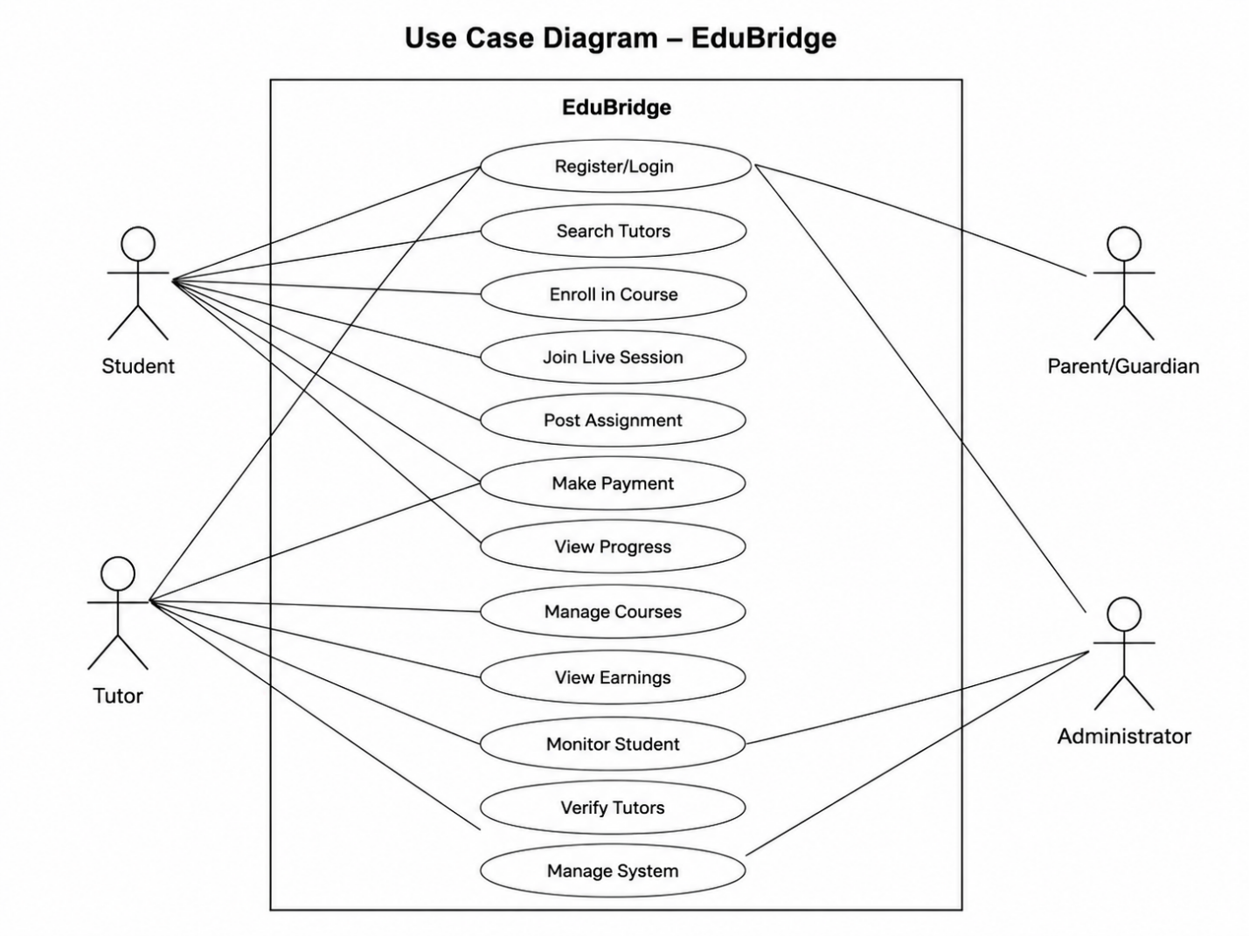
Chapter 3: Analysis
3.1 Analysis Overview
The analysis phase explains how EduBridge should behave from the user’s point of view and how the main system objects interact with one another. This chapter focuses on the domain model, data flow diagrams, activity diagrams, and system sequence diagrams. The purpose is to understand system behavior before moving toward detailed design.
3.2 Domain Model
The domain model represents the main real-world concepts of EduBridge and their relationships.
Main Domain Classes
Class | Description
User | General account entity for all system users.
Student | A learner who enrolls in courses, attends sessions, posts assignments, and makes payments.
Tutor | A teacher who creates courses, teaches sessions, submits proposals, and receives payments.
ParentGuardian | A user who monitors linked student progress.
Administrator | A user who manages verification, disputes, and moderation.
TutorProfile | Stores tutor qualification, subjects, experience, price, and verification status.
Course | Represents a structured learning course created by a tutor.
Module | Represents a section of a course.
Lesson | Represents individual learning content inside a module.
Enrollment | Connects a student with a course and stores progress.
LiveSession | Represents a scheduled or active class between tutor and student.
AssignmentRequest | Represents assignment or project work posted by a student.
Proposal | Represents tutor response to a request or assignment.
Payment | Represents a financial transaction.
EscrowTransaction | Represents held payment until completion.
Review | Represents feedback and rating.
CommunityPost | Represents a question, discussion, or answer.
Notification | Represents system alerts and messages.
AIReport | Represents AI-generated summaries or recommendations.
3.3 Data Flow Diagrams
Data Flow Diagrams describe how information moves between users, system processes, and data stores.
3.3.1 Level 0 DFD
The Level 0 DFD breaks EduBridge into major processes.
Processes
1.0 Manage Users and Authentication
2.0 Manage Tutor Matching
3.0 Manage Courses and Enrollment
4.0 Manage Live Sessions
5.0 Manage Assignments and Projects
6.0 Manage Payments and Escrow
7.0 Manage Reports, AI, and Administration
3.3.2 L evel 1 DFD: Manage Users and Authentication
Inputs include registration data, login credentials, password reset requests, and verification tokens. The process validates input, checks duplicate accounts, stores user data, sends verification email, and creates authenticated sessions.
Outputs include account creation status, login token, password reset link, and error messages.
3.3.3 Level 1 DFD: Tutor Matching
Inputs include search keywords, subject filters, location preference, availability, price range, and student learning history. The process retrieves tutor profiles, applies filters, uses AI ranking, and returns recommended tutors.
Outputs include tutor list, tutor details, availability, and recommendation scores.
3.3.4 Level 1 DFD: Course Management
Inputs include course title, description, modules, lessons, quizzes, resources, enrollment request, and progress updates. The process stores course content, manages enrollments, updates progress, and generates certificates.
Outputs include course catalog, lesson content, enrollment confirmation, progress report, and certificate.
3.3.5 Level 1 DFD: Live Session Management
Inputs include session schedule, join request, chat messages, files, attendance data, and recording metadata. The process creates session room, manages live communication, records attendance, and generates AI summary.
Outputs include session link, chat history, attendance record, recording URL, and summary.
3.3.6 Level 1 DFD: Assignment Marketplace
Inputs include assignment description, attachments, deadline, budget, tutor bid, submission, and review. The process creates assignment listing, collects proposals, manages acceptance, stores submissions, and updates assignment status.
Outputs include listing status, proposal list, accepted bid, submitted work, revision request, and completion status.
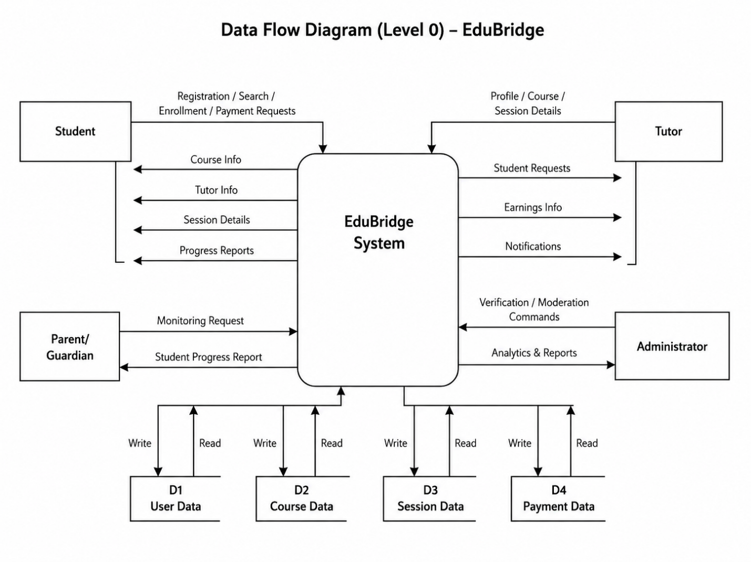
3.3.7 Level 1 DFD: Payment and Escrow
Inputs include payment amount, payment method, transaction type, refund request, and dispute request. The process creates payment intent, contacts gateway, stores transaction, manages escrow, releases funds, or processes refund.
Outputs include payment confirmation, escrow status, payout status, refund decision, and transaction receipt.
3.4 Activity Diagrams
Activity diagrams show step-by-step workflows of major use cases.
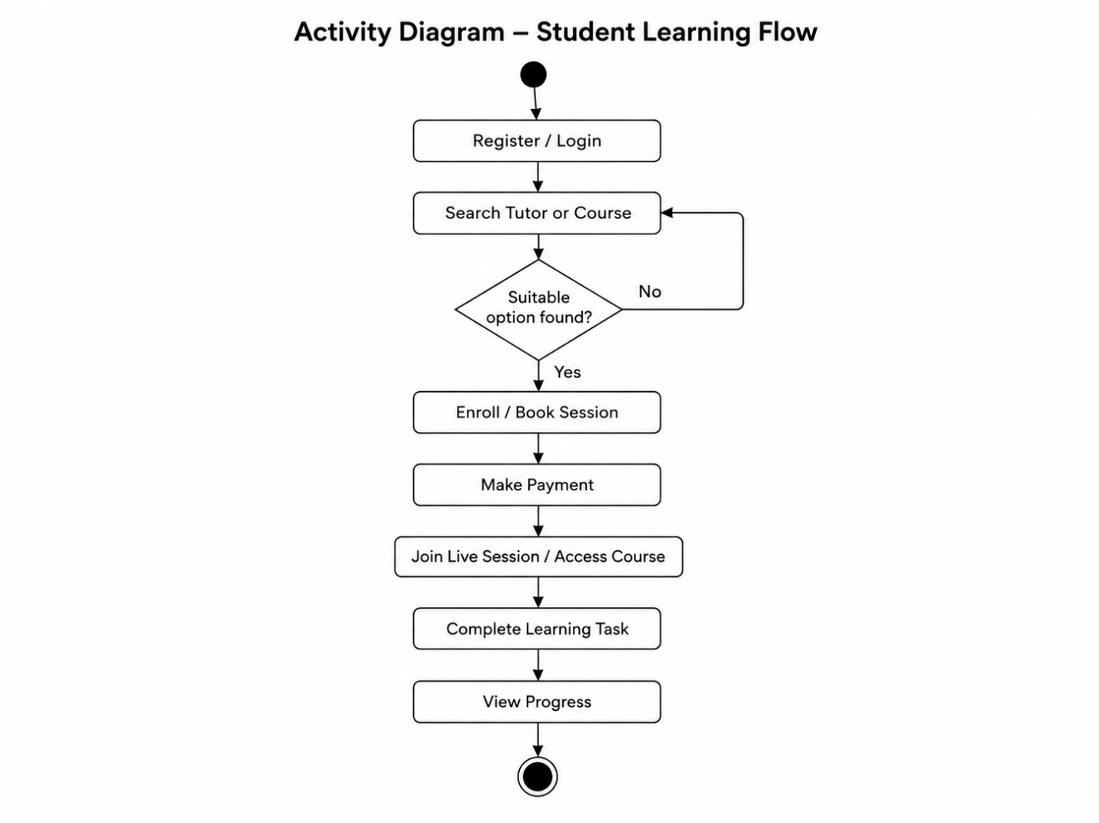
3.5 System Sequence Diagrams
System Sequence Diagrams show interactions between users and the system.
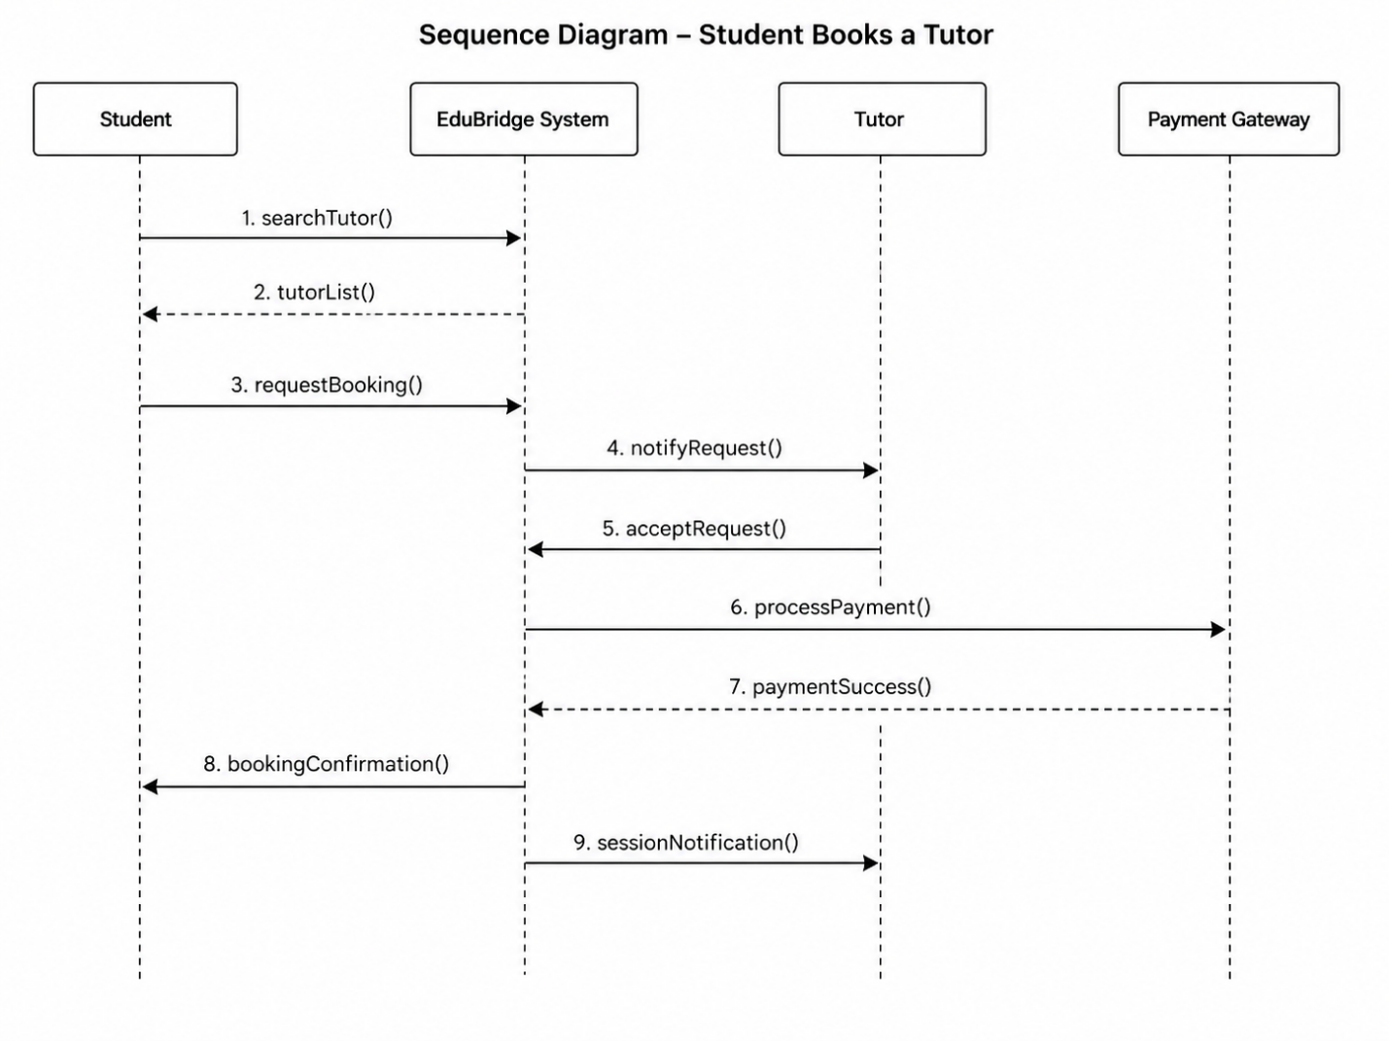
Chapter 4: Design
4.1 Design Overview
The design chapter explains how EduBridge will be structured internally. It includes the architecture, class design, sequence design, database design, interface design, and component responsibilities. The main goal of the design is to convert analysis-level requirements into a clear technical solution.
4.2 Architectural Design
EduBridge follows a layered and service-oriented architecture. The frontend communicates with the backend through APIs. The backend handles business logic and connects with databases, cloud storage, payment gateway, email service, and AI services.
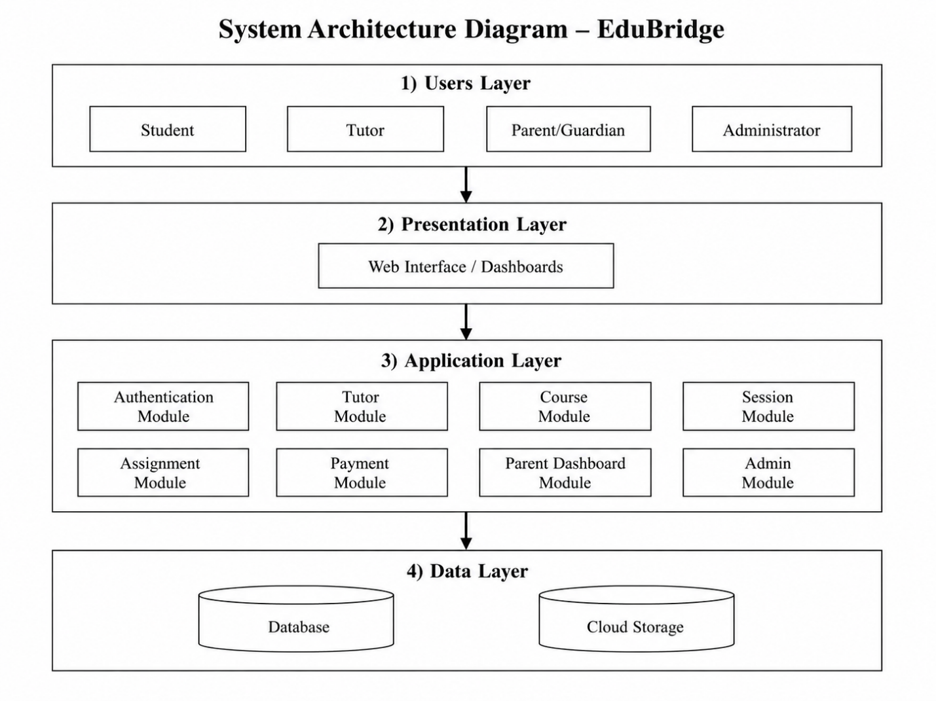
Main Architecture Layers
Layer | Responsibility
Presentation Layer | Provides user interface for students, tutors, parents, and administrators.
API Gateway Layer | Receives client requests, checks authentication, and routes requests to services.
Business Logic Layer | Contains services for users, courses, sessions, assignments, payments, AI, and admin operations.
Data Layer | Stores users, courses, sessions, assignments, payments, reports, and community data.
External Integration Layer | Connects with payment gateway, email service, cloud storage, and AI APIs.

4.3 Component Design
Component | Main Responsibility
User Component | Handles registration, login, profile, and role management.
Tutor Component | Handles tutor profile, verification, availability, and subject listing.
Course Component | Handles course creation, modules, lessons, enrollments, and certificates.
Session Component | Handles scheduling, live rooms, attendance, and summaries.
Assignment Component | Handles assignment posting, bidding, submission, and approval.
Payment Component | Handles transactions, escrow, refunds, and payout records.
Parent Dashboard Component | Handles student progress reports and monitoring.
Community Component | Handles posts, answers, comments, votes, and badges.
AI Component | Handles recommendations, summaries, and learning suggestions.
Admin Component | Handles verification, moderation, disputes, analytics, and audit logs.

